PRE Cost Price Calculation and Final Cost Price Calculation
Cost Price Calculation Module
Overview
The Cost Price Calculation Module determines both estimated and final product costs, and subsequently calculates the selling price based on predefined margins. The module supports multiple warehouse types and incorporates ten (10) cost components.

1. Cost Calculation Stages
1.1 Pre-Cost Calculation
The pre-cost represents an estimated product cost and is calculated using:
- Suggested purchase orders downloaded from ORDERSTREAM
- Quoted freight charges provided by the freight forwarder
This stage is used for planning and forecasting before the final Purchase Order is approved.

1.2 Final Cost Calculation
The final cost reflects the actual product cost and is calculated using:
- Confirmed supplier invoices
- Final freight charges from the freight forwarder
This ensures accurate cost determination based on real expenses.

2. Suggested Purchase Order, Purchase Order and Cost Calculation Flow
2.1 Suggested Purchase order creation
Suggested Purchase Orders (SPOs) are created in the ORDERSTREAM application and must be manually downloaded in Excel format to be retrieved within this module.

2.2 Purchase order creation
Purchase Orders (POs) are created in the ORDERSTREAM application and after creation, each PO is automatically registered in the VIP Purchase Order Database.

2.3 Selection
Users can select one or multiple Suggested Purchase Orders from the downloaded Excel sheets or Purchase Orders from the VIP database to perform cost and selling price calculations.

2.4 Automatic or Manual Entries
For the Pre-Cost calculation, Freight charges must be automatically retrieved from the Freight Database.
While doing the final cost calculation, users are required to manually enter or adjust the following:
- Ocean Freight
- Inland Freight (if applicable)
- Additional charges (default values are retrieved from system tables but can be modified if necessary)

2.5 Calculation
The system calculates:
- All cost components
- Final cost price per warehouse
- Selling price per warehouse

3. Cost Components

The system calculates the following ten (10) cost components per SKU, all expressed in local currency:
- FOB Price
Retrieved from the selected purchase order(s).
- Inland Freight
Transport cost from supplier to port.
- Ocean Freight
Sea freight cost
- Local Handling
Port handling, documentation, and terminal charges (system-generated, editable).
- Duties
Customs duties based on product classification and customs value. The quantity liters have to be calculated if it is an alcoholic beverage. Tariff is retrieved from table GS_2012 depending on the product GS_Code
- Economic Surcharge
Applicable regulatory or economic surcharges. Tariff is retrieved from table GS_2012 depending on the product GS_Code
- Import Tax
VAT or similar tax calculated on the taxable base. Tariff is retrieved from table GS_2012 depending on the product GS_Code
- Insurance
Calculated based on insured value and applicable insurance rate.
- Transport
Domestic transport from port to warehouse (system-generated, editable).
- Unloading
Warehouse unloading costs (system-generated, editable).

4. Final Cost Price Calculation
The Final Cost Price depends on the warehouse type where the goods are received.
4.1 Supported Warehouse Types
- Duty Free Warehouse
- Duty Paid Warehouse
- Store Warehouse

4.2 Calculation Rules
Duty Free Warehouse
For Duty Free warehouses, the Final Cost Price is calculated as:
Final Cost Price =
FOB Price + Inland Freight + Ocean Freight + Local Handling + Insurance + Transport + Unloading
Note: Duties, Economic Surcharge, and Import Tax are excluded.

Duty Paid and Store Warehouses
For Duty Paid and Store warehouses, the Final Cost Price is calculated as:
Final Cost Price =
FOB Price + Inland Freight + Ocean Freight + Local Handling + Duties + Economic Surcharge + Import Tax + Insurance + Transport + Unloading
Note: All ten cost components are included.

5. Selling Price Calculation
Once the Final Cost Price is determined, the system calculates the Selling Price by applying a predefined product margin.

Source Tables:
- POHDRT → Purchase order Header Table
- PODTLT → Purchase Order Detail Table
- ITEMT → For product Information
- ITEM_FOB_PRICES → Item FOB Prices
- RANKER_553 → For Current prices 01 till 11
- RANKER_99T → For Costs 01 till 10
- FREIGHT FORWARDER → Freight Forwarders Info to select from
- GOODSCLASSIFICATION → Classification of goods liked to GS_2012
- GS_2012 → EXCEL SHEET with Customs Tariffs

PURCHASE ORDER HEADER (POHDRT):
The Purchase Order Header Table is registered in VIP in table POHDRT
This table contains the following relevant data:

POHDRT
PHWHSE (Warehouse)
PHPO# (Purchase Order Number
PHBORW (BEER or WINE Order)
PHBRVR (Supplier Code)
PHORDT (Order Date format YYYYMMDD)
PHSHDT (Order Ship date format (YYYYMMDD)
PHSHDT (Order Arrival Date format YYYYMMDD)
PHCON# (Container Number)
PHOQT (Total Order Quantity)
PHWEIG (Total Order Weight)
PHLTRS (Total Liters)
PHTOT$ (Total Amount)
PHOVR# (Order Vendor Number)
PHLINE (Total Order Regels)
PHSTAT (Order Status)

PURCHASE ORDER DETAIL TABLE (PODTLT):
The Purchase Order Detail Table is registered in VIP in table PODTLT
This table contains the following relevant data:

PODTLT
PDWHSE (Warehouse)
PDPO# (Purchase order Number)
PDLINE (Purchase order Line Number)
PDITEM (Item Number)
PDOQTY (Order Quantity)
PDRQTY (Received Quantity)
PDWEIG (Total Line Weight)
PDLTRS (Total Line Liters)
PDCST$ (Item Price)
PDUNIT (Units per Case)
PDSITEM (Supplier Item Code)
PDCDDT (Code Date)
PDBSW (Beer or Wine)
PDCLAS (Product Class)
PDBRVR (Supplier Code)
PDBRAN (Brand Code)
PDSUB (Sub Code)
PDRDAT (Receive Date)
PDSTAT (Order Status)

ITEM_FOB_PRICES
IT_Code (Item Code)
IT_Purchase_Price
IT_Commodity (Customs Code)

RANKER_553
ITEM
DEL
DI
DUTY P
DUTY FR
COST
PR 01
PR 02
PR 03
PR 04
PR 05
PR 06
BEEROH
WINEOH
UM
B6%
B9%
W6%
W9%
TX?
PR 07
PR 08
PR 09
PR 10
PR 11

RANKER_99T
WHSE
ITEM
DESCRIPT
U/C
COST01
COST02
COST03
COST04
COST05
COST06
COST07
COST08
COST09
COST10
TOTAL
COST99

FREIGHT FORWARDERS
FF_CODE
FF_NAME
FF_ADDRESS_1
FF_ADDRESS_2
FF_CITY
FF_COUNTRY
FF_PHONE_1
FF_PHONE_2
FF_EMAIL
FF_CONTACT
FF_CURRENCY

FREIGHT CHARGES:
FOR THE FREIGHT CHARGES, PLEASE CONSULT THE FREIGHT DATABASE DOCUMENTATION

GOODSCLASSIFICATION
citemno
cdescrip
ccommodity
chtcode
nvolume
nbtlcontent
ncaseqty
ntarrif01
ntarrif02
ntarrif03
ntarrif04
ntarrif05
ntarrif06

GS_2012
HS6_COD
TAR_PR1
TAR_DSC
UOM_COD1
UOM_COD2
TAR_T01
TAR_T02
TAR_T04
TAR_T05
TAR_T06
TAR_T07
TAR_T08
TAR_T09
TAR_T10
TAR_T12

SYSTEM_TABLE
COMP_CODE
COMP_NAME
COMP_ADDRESS
COMP_CONTACT
COMP_TEL
COMP_FAX
COMP_EMAIL
COMP_CURR_LOCAL
COMP_CURR_USD
COMP_RATE_USD
COMP_DOC_NUMBER
COMP_DOC_EMAIL
COMP_INSURANCE
COMP_TRANSPORT
COMP_UNLOADING
COMP_LOCAL_HANDLING
COMP_FWCODE
COMP_FWNAME
COMP_FWCURR
COMP_SM01_CODE
COMP_SM01_EMAIL
COMP_SM02_CODE
COMP_SM02_EMAIL
COMP_SM03_CODE
COMP_SM03_EMAIL
COMP_PC_EMAIL
COMP_OZ_FACTOR
COMP_LITER_MULTIPLIER
COMP_PRICE_CHANGE_PERC
COMP_PRICE_CHANGE_AMNT
COMP_STORE_RETAIL_PERC
COMP_STORE_ALLIANCE_PERC
COMP_STORE_NORSA_PERC
COMP_PRICE_CHANGE_YEAR
COMP_PRICE_CHANGE_SEQ
COMP_EMAIL_PURCH_DEP
COMP_EMAIL_APPROVAL
COMP_PATH_COST_CHANGES
COMP_PATH_PRICE_CHANGES
COMP_PATH_COST_CALC
COMP_EMAIL_COST_CHANGE
COMP_EMAIL_CONFIRM_MNGR
COMP_EMAIL_PRICE_CHANGES_FINANCE

COST_CALC_FIN: File that groups Purchase Orders together in case of a consolidation:

COST_CALC_FIN
CC_Calc_Number
CC_Calc_Date
CC_Forwarder_Code
CC_Forwarder_Name
CC_CurrCode (Currency Code)
CC_CurrRate (Currency Rate)
CC_Freight (Ocean Freight Charges)
CC_Transport (Transport Charges)
CC_Unloading (Unloading Charges)
CC_Local Handling (Local Handling Charges)
CC_TotWeight (Container Ttal Weight)
CC_Status (Container Status)
CC_TotOrd (Total Orders in Container)
CC_TotQty (Total Cases in the Container)

COST_CALC_PO_HEAD_FIN
CCPH_Calc_Number
CCPH_LMPoNo
CCPH_VendNo
CCPH_VendName
CCPH_CurrCode (Currency Code)
CCPH_CurrRate (Currency Rate)
CCPH_CurrRate_Cust (Currency Rate Customs)
CCPH_Inv_Number (Invoice Number)
CCPH_Inv_Date (Invoice Date)
CCPH_Local Handling (Local Handling Charges)
CCPH_Duties (Total Paid Duties)
CCPH_Econ_Surch (Container Status)
CCPH_OB (Total Paid OB)
CCPH_Weight (Total Purchase Order Weight)
CCPH_Freight (Freight calculated with Currency Rate
CCPH_Freight_Cust (Freight calcul;ated with Currency Customs)
CCPH_Transport (Transport charges of the Purchase Order)
CCPH_Unloading (Unloading charges of the Purchase order)
CCPH_Local_Handling (Local Habdling of the Purchase Order)
CCPH_TotQty (Total Qty cases of the Purchase order)
CCPH_TotAmount_FC_Org (Original Total Amount of Purchase order)
CCPH_TotAmount_FC (Orioginal Total Amount of Purchase Order)
CCPH_TotAmount (Total Amopunt Purchase Order in Local Currency)
CCPH_TotWeight (Total Weight of Purchase order)
CCPH_Insurance (Total Insurance of Purchase Order)
CCPH_Check_Qty (Total Qty entered to check the Qty)
CCPH_Check_Inv_Amnt_FC (Amount entered to check P.O. Amount)
CCPH_User (User doing the cost calculation)
CCPH_Cost_11060_Ext (Total Cost 11060)
CCPH_Cost_11010_Ext (Total Cost 11010)
CCPH_Cost_11020_Ext (Total Cost 11020)
CCPH_Add_Cost_FC (Additional Cost Foreign Currency)
CCPH_Inland_Freight_FF (Inland Freight Freight Forwarder)
CCPH_Inl_Frght_CurrCode (Currency Inland freight)
CCPH_Inl_Frght_Rate (Currency Rate Inland Freight)
CCPH_Inl_Frght_Rate_Cust (Currency Rate Customs inland freight)
CCPH_Vend_11060_Exist (Y/N if Vendor is for 11060)
CCPH_Vend_11020_Exist (Y/N if Vendor is for 11020)
CCPH_Vend_CIF Exist (Y/N if Vendor is CIF)
CCPH_Vend_Weight_Exist (Y/N if calculation is on Weight)
CCPH_Status (Status of the Purchase Order)
CCPH_Created_By ( User that created Cost Calculation)
CCPH_Confirmed_By (User that confirmed the Cost Calculation)
CCPH_Approved_By (User that approved the Price calculation)
CCPH_Remarks_ABORT (emarks on the Purchase Order)
CCPH_Price_Change_Doc_Seq (Sequence Number of Price Change)
CCPH_WareHouse (Warehouse that receives the products)

COST_CALC_PO_DET_FIN
CCPD_Calc_Number
CCPD_LMPoNo
CCPD_ItemNo
CCPD_Item_Descr
CCPD_UnitCase
CCPD_UM
CCPD_LiterS
CCPD_CLiter
CCPD_Liter_Factor
CCPD_Tot_Liters
CCPD_Tot_CLiter
CCPD_OrdQty
CCPD_Free_Goods
CCPD_Cost_Org
CCPD_Cost
CCPD_Total_Inv_FC_Org
CCPD_Total_Inv_FC
CCPD_Weight
CCPD_FOB_Price
CCPD_FOB_Price_Tot
CCPD_FOB_Price_Tot_Cust
CCPD_HandelsBenam
CCPD_GoedCode
CCPD_Inland_Freight
CCPD_Inland_Freight_Cust
CCPD_Freight
CCPD_Freight_Cust
CCPD_Local_Handl
CCPD_Duties
CCPD_Duties_UnRound
CCPD_Duties_Tot
CCPD_Econ_Surch
CCPD_Econ_Surch_UnRound
CCPD_Econ_Surch_Tot
CCPD_OB
CCPD_OB_UnRound
CCPD_OB_Tot
CCPD_Insurance
CCPD_Transport
CCPD_Unloading
CCPD_Qty_11060
CCPD_Cost_11060
CCPD_Cost_11060_Ext
CCPD_Qty_11010
CCPD_Cost_11010
CCPD_Cost_11010_Ext
CCPD_Qty_11020
CCPD_Cost_11020
CCPD_Cost_11020_Ext
CCPD_VIP_Old_Unit_Cost
CCPD_FOB_Price_Old
CCPD_Inland_Freight_Old
CCPD_Freight_Old
CCPD_Local_Handl_Old
CCPD_Duties_Old
CCPD_Econ_Surch_Old
CCPD_OB_Old
CCPD_Insurance_Old
CCPD_Transport_Old
CCPD_Unloading_Old
CCPD_Old_Cost_11060
CCPD_Old_Price_11060_Case
CCPD_Old_Cost_11010
CCPD_Old_Price_11010
CCPD_Old_Price_03
CCPD_Old_Price_04
CCPD_Old_Price_05
CCPD_Old_Price_07
CCPD_Old_Price_08
CCPD_Old_Price_09
CCPD_Old_Price_10
CCPD_Old_Price_11
CCPD_Price_Change_Sel
CCPD_New_Price_11010_Case
CCPD_New_Price_11060_Case
CCPD_Selling_Units
CCPD_Margin_Perc
CCPD_Margin_Perc_Last
CCPD_Margin_Perc_11060
CCPD_Margin_Perc_11060_Last
CCPD_Margin_Perc_Test
CCPD_Created_By
CCPD_Confirmed_By
CCPD_Approved_By
CCPD_Do_Not_Order_Sel
CCPD_Miniature
CCPD_NEW_Item
CCPD_Changed_Price_Btl
CCPD_Changed_Price_Btl_11060
CCPD_Changed_Margin_Perc
CCPD_Changed_Margin_Perc_11060
CCPD_BONDED_Item
CCPD_Margin_Perc_11020
CCPD_Margin_Perc_11020_Last
CCPD_Margin_Perc_07_Last
CCPD_Margin_Perc_08_Last
CCPD_Margin_Perc_09_Last
CCPD_Margin_Perc_10_Last
CCPD_Margin_Perc_11_Last
CCPD_Warehouse
CCPD_No_Price_Change
CCPD_New_Price_03_Case
CCPD_New_Price_04_Case
CCPD_New_Price_05_Case
CCPD_New_Price_07_Case
CCPD_New_Price_08_Case
CCPD_New_Price_09_case
CCPD_New_Price_10_Case
CCPD_New_Price_11_Case
CCPD_New_Margin_Perc_01
CCPD_New_Margin_Perc_03
CCPD_New_Margin_Perc_04
CCPD_New_Margin_Perc_05
CCPD_New_Margin_Perc_06
CCPD_New_Margin_Perc_07
CCPD_New_Margin_Perc_08
CCPD_New_Margin_Perc_09
CCPD_New_Margin_Perc_10
CCPD_New_Margin_Perc_11
CCPD_NORSA_PERC
CCPD_RETAIL_PERC
CCPD_ALLIANCE_PERC
CCPD_New_Price_11010_Case_Cpy
CCPD_New_Price_11060_Case_Cpy
CCPD_New_Price_03_Case_Cpy
CCPD_New_Price_04_Case_Cpy
CCPD_New_Price_05_Case_Cpy
CCPD_New_Price_07_Case_Cpy
CCPD_New_Price_08_Case_Cpy
CCPD_New_Price_09_case_Cpy
CCPD_New_Price_10_Case_Cpy
CCPD_New_Price_11_Case_Cpy
CCPD_New_Margin_Perc_01_Cpy
CCPD_New_Margin_Perc_03_Cpy
CCPD_New_Margin_Perc_04_Cpy
CCPD_New_Margin_Perc_05_Cpy
CCPD_New_Margin_Perc_06_Cpy
CCPD_New_Margin_Perc_07_Cpy
CCPD_New_Margin_Perc_08_Cpy
CCPD_New_Margin_Perc_09_Cpy
CCPD_New_Margin_Perc_10_Cpy
CCPD_New_Margin_Perc_11_Cpy

User Interfaces for the Cost Calculation process

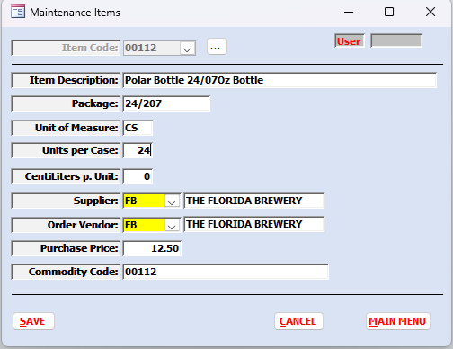

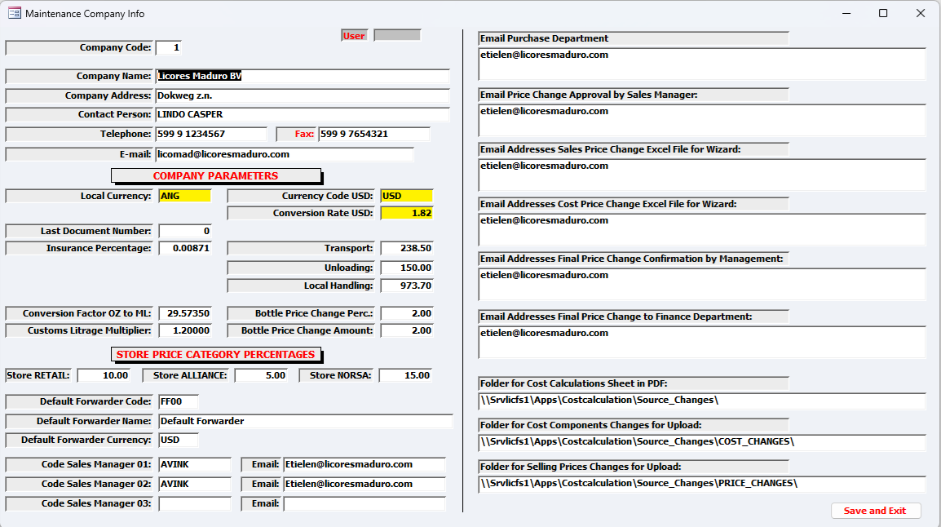
Both the Pre-Cost Calculation and the final cost calculation can use the same interface with the difference that the pre-cost calculation will use the Freight charges from the Freight Database.
With regards to the Final Cost calculation, the freight costs must be manual entered.

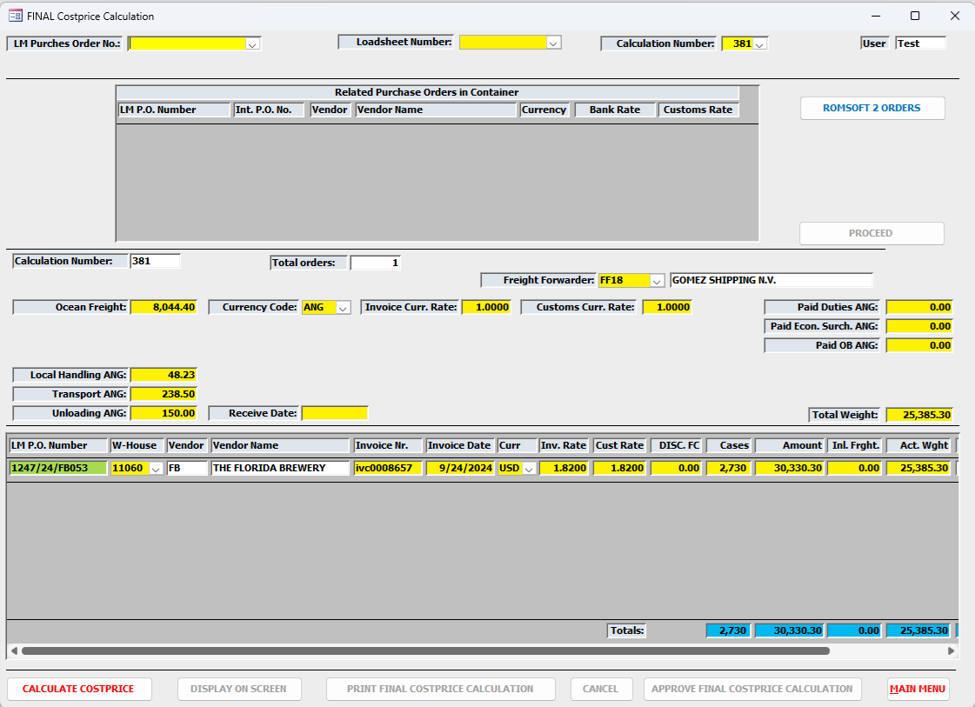
By pressing the green purchase Order number.
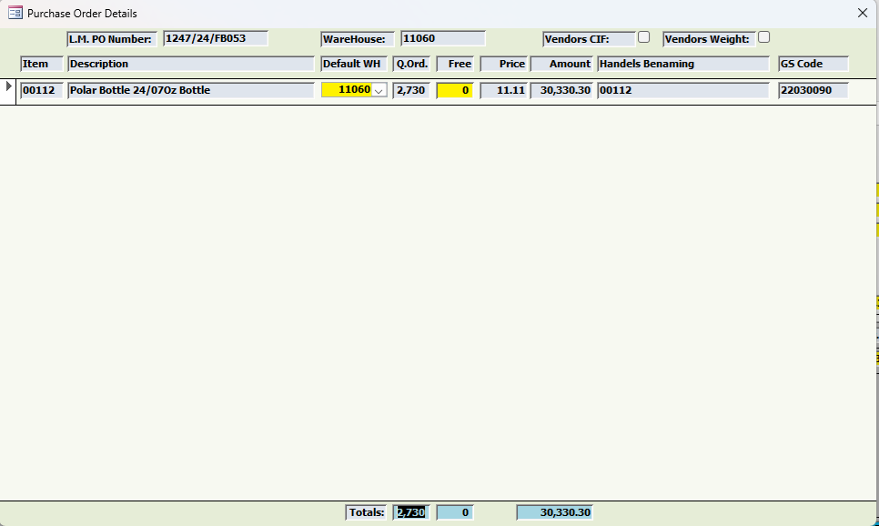

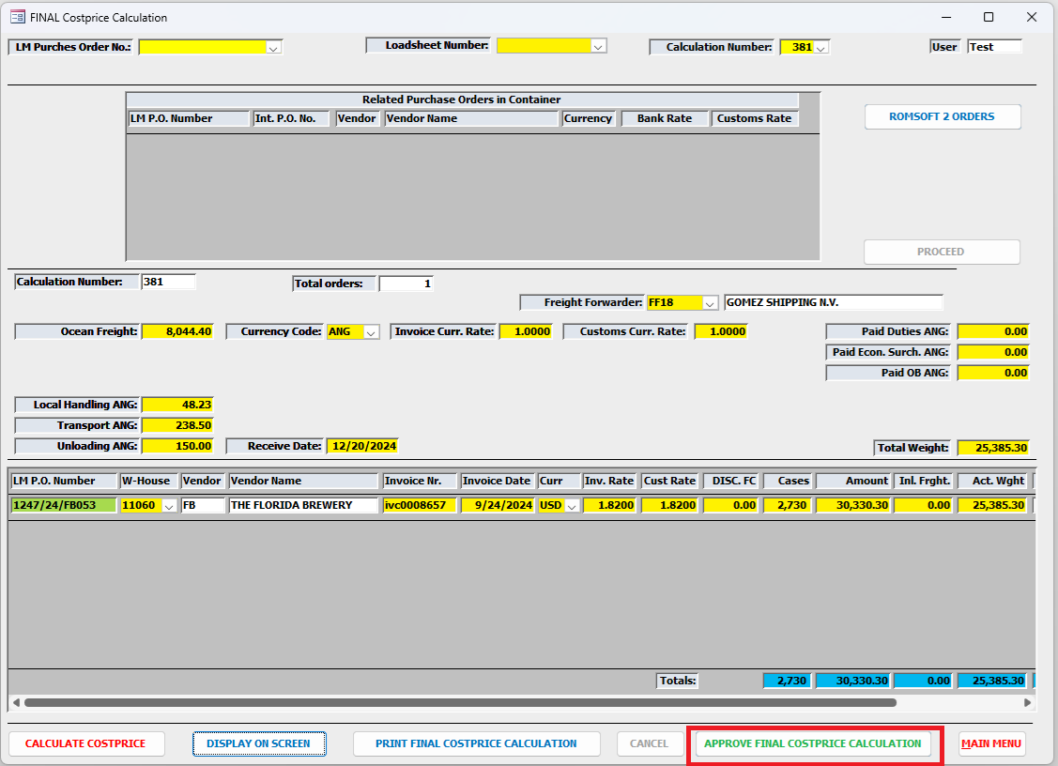

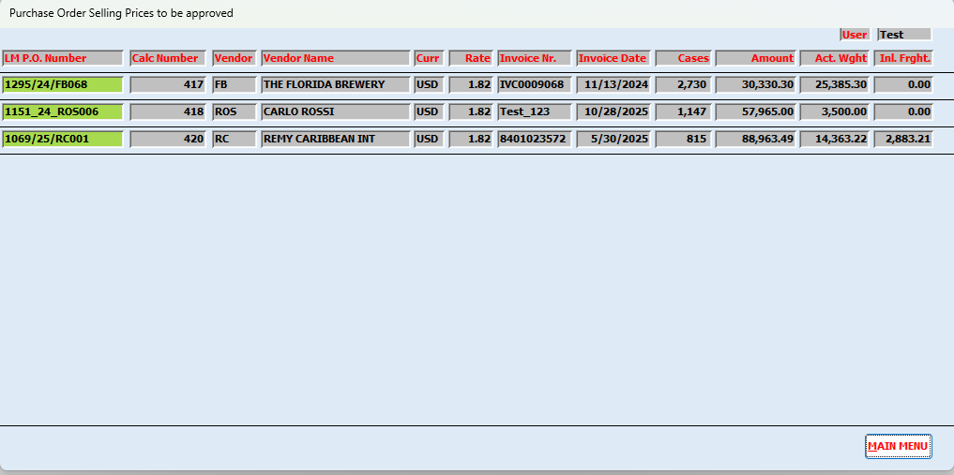

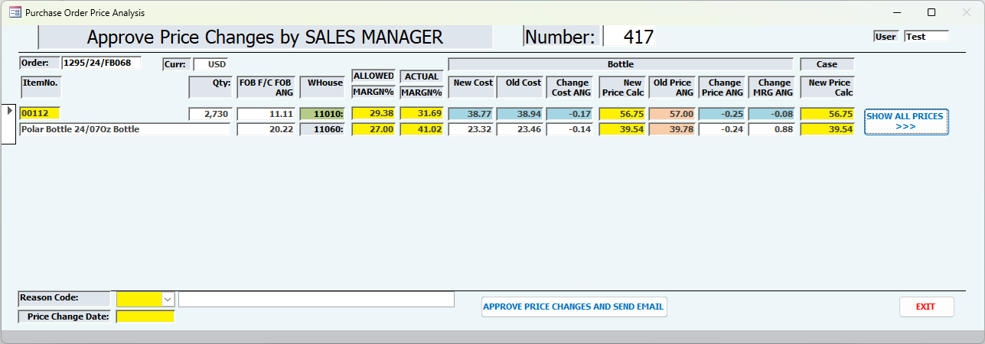

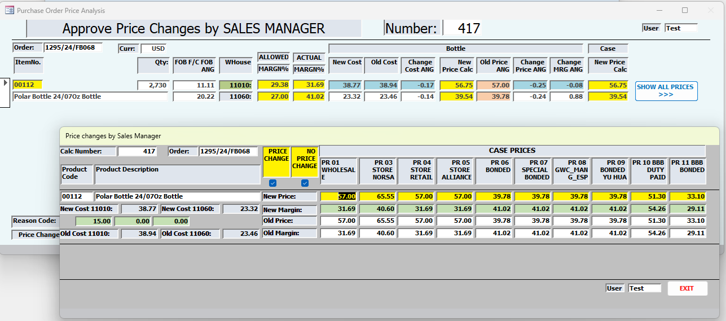

Deliveries of the Cost Calculation process:
The following deliveries are for both the pre-cost calculation as for the final cost calculation.

